An Introduction to Discovery-based inquiry
An approach to learning in the Early Years
By Deb Vietri January 2018

The nature of the learner in the Early Years compels us to think carefully about our pedagogical approaches, and design learning that values the natural curiosity and individuality of young children. The Discovery-based inquiry approach values the prior knowledge, interests and experiences that young children bring with them to school, as well as building new experiences as a springboard for extending children’s curiosity and scaffolding further learning. Discovery-based inquiry is an approach to learning underpinned by principles, not a program. Schools implement the approach to suit the characteristics of their students and setting, and so it can look different in each school. What is constant however, is the core structure of the approach: student-initiated inquiry (Discovery), teacher-initiated inquiry (inquiry investigations), the development of learner skills and dispositions, and the interweaving of literacy and numeracy in authentic and purposeful ways. The underpinning philosophy characterised by the learning principles is also constant across schools adopting the Discovery-based inquiry approach.

Learning Principles:
- Learning dispositions empower students (emphasis on teaching students ‘how to’ learn and developing learning dispositions that will empower them to become self-motivated, self-managing learners)
- Pedagogy of inquiry (giving purpose to learning, harnessing children’s natural curiosity, creating wonder and awe, questioning and seeking answers enables students to construct new knowledge in a way that is meaningful)
- Power of play, a playful pedagogy (play as a context for early inquiry into; themselves- identity as a person and as a learner; themselves as social beings living in community with others; the world around them. Being playful as a disposition when testing out ideas and discovering in a safe and familiar context, making choices without fear of failure)
- Integrated teaching and learning (making connections across disciplines, holistic learning, not teaching in silos, creating real purposes for literacy, numeracy, collaboration, etc)
- Respect for each individual (recognising and being inclusive of the diversity of each child- culture, interests, talents, learner traits and qualities, allowing for different pathways, recognising that all students have things to contribute and giving them voice)
- The environment as the 3rd teacher (all children influence and are affected by the environments that surround them VEYLDF 2016 p5. Physical spaces hold the potential to influence what and how children learn)
- Look, listen and learn: Assessment for learning (Powerful ways of finding out more about students include listening and watching. Knowledge of individual students and the learning continuum enables teachers to influence and guide further learning. Knowing the developmental continuum of learning enables us to act on our assessment, planning and influencing the next step in each child’s learning)
- Feedback enhances achievement (the most powerful single modification that enhances achievement is feedback- John Hattie. Through strategic and explicit learning conversations teachers have the opportunity to orchestrate and shape successful learning for their students)

Core elements

There are 4 core elements that provide the framework for the Discovery-based inquiry approach:
· Inquiry Investigations (teacher-initiated inquiries
· Discovery (student-initiated inquiries)
· Development of learner skills and dispositions
· Authentic and purposeful links to literacy and numeracy

The core elements are not intended to operate in silos, rather they interweave as seamlessly as possible. Discovery and Inquiry investigations complement one another and provide a context for both the purposeful learning and application of literacy and numeracy skills as well as the students’ capacities as effective learners.

Inquiry investigations (teacher-initiated inquiry)
We want to give our students time to explore what intrigues them, and we want to make sure they visit the important sites they might miss without guidance. Teachers need to map out the landscape and highlight some of the most important places to stop. Tina Blythe.
Inquiry investigations enable teachers to broaden the children’s horizons and experiences, potentially sparking new interests and ideas. They also provide the opportunity for explicit teaching of inquiry skills and dispositions. Teachers strategically plan experiences where students can engage with concepts or ‘big ideas’ through an inquiry approach. Teachers identify concepts as being potential for inquiry and investigation. These concepts can come from ‘big ideas’ in the curriculum, community events, or teachers’ knowledge of the students. The planned shared experiences provide a springboard for student curiosity and wonderings, as well as developing a shared vocabulary. For example, students may walk to a local creek or park to explore the concept of living things or natural environments. This experience will enable students to develop a topic vocabulary and trigger wonderings that can be further investigated through a directed inquiry. Teachers use a variety of strategies to introduce students to different inquiry processes (eg scientific inquiry, researching, design thinking, problem-solving and field studies) through modelled and shared inquiries. As students become familiar with the processes and skills they engage in more guided and independent inquiries to explore and investigate their own interests and questions, or to show their learning.

Discovery (student-initiated inquiry)
Discovery is a time when students are empowered to make decisions about their own learning. They choose the learning they want to engage in, who they do this with, and where they do it. Teachers create environments that encourage children to investigate, play, create, discover and experiment in different ways. They provide materials and provocations to stimulate different kinds of thinking and responses. Inspired by Reggio Emilia, teachers endeavour to honour the ‘Hundred languages of Children’ when designing environments and creating learning opportunities.

Children learn as they play. Most importantly, in play children learn how to learn.
O Fred Donaldson

Whilst it is always playful, Discovery is first and foremost a learning time. Play is the entry point into Discovery. Children are usually very familiar and comfortable with play, in fact they are experts! However, as children develop as inquirers they began to take on more intentional projects instigated and managed by themselves, with support and guidance from the teacher. Discovery is a time when students can apply and practise their skills (literacy, numeracy, learner skills and dispositions) and their understandings of different inquiry processes for their own purposes.

Discovery provides opportunities for students to learn more about; themselves; how to live and work with others; and the world they live in. There are a wide range of possible learning foci and outcomes including the development of; oral language; social and personal management skills; literacy and numeracy skills, fine and gross motor co-ordination, a variety of domain specific skill sets; and learning dispositions such as curiosity, creativity, collaboration, persistence, resilience, and flexibility.

Teachers are designers, and co-designers with their students, of the environment. They set up materials, opportunities and stimuli to engage students in a variety of explorations that may be related to the inquiry investigation, or may be related to student interest or other areas of their learning. The teacher’s role during Discovery is extremely important as an influencer and mentor, and it is imperative that the teacher is 100% present to the students 100% of the time. The teacher could be doing a range of things during Discovery including; engaging in learning conversations with students, observing, co-playing, assisting with problem solving, questioning, redirecting undesired behaviours, encouraging children who have difficulty entering into play, and challenging others who are ready to ‘stretch’ their learning.
Introductions at the start of Discovery are an opportunity to; explicitly teach skills, dispositions or desired behaviours; model particular kinds of thinking, brainstorm and explore different ideas or contexts. Introductions should be well planned and responsive to children’s needs. Share time gives children the opportunity to articulate their learning and have their ideas and efforts validated. It is also an opportunity for children to learn from their peers and give each other feedback.
Development of learner skills and dispositions
“A disposition is a pattern of behavior exhibited frequently ... in the absence of coercion ... constituting a habit of mind under some conscious and voluntary control ... intentional and oriented to broad goals” (Katz 1993)
Another important characteristic of children’s dispositions is that they are environmentally sensitive—meaning they are acquired, supported, or weakened by interactive experiences in an environment with significant adults and peers (Bertram & Pascal 2002).

Quoted in ‘Why Children’s Dispositions Should Matter to All Teachers’: Head Start Early Childhood Learning and Knowledge Centre
If we support students to develop desirable dispositions and learning to learn skills, we will give them a toolkit to become independent learners. Developing desirable learning dispositions in students that will empower them to become self-managing, self-motivated learners takes time and consistency. Once again Discovery and Inquiry investigations are great contexts for teaching and reinforcing learning skills and dispositions, however it is important to remember that learning competencies span all areas of the curriculum. It is important to have a common understanding and language amongst all members of the school community in order for a culture of positive and effective learning to develop. Many schools develop a core list of learning dispositions in order to facilitate this. Discovery is an optimal time for teachers to bring attention to learning dispositions; through learning conversations, explicit teaching during an introduction, goal setting, and share time.

Authentic and purposeful links to literacy and numeracy
The experiences students have in both the inquiry investigations and discovery provide rich opportunities for literacy and numeracy development. Using students own experiences to develop oral, written and visual texts ensures students have an understanding of content and context, so explicit teaching can focus on learning; how to read, how to write, how to construct and interpret texts. Essential vocabulary is developed before and during the experience, and is then used after the experience in both oral discussions and writing. Shared and independent texts created after the experience are highly supportive and can be used to explicitly teach reading and comprehension strategies.

Written, visual or electronic texts can be used when investigating class wonderings or individual student wonderings. Teachers can model how to use texts as a finding out strategy strengthening student’s comprehension skills and their understanding of how texts work.

Likewise, experiences in Discovery and Inquiry investigations can provide real life contexts for mathematical exploration and use of numeracy skills. Role-playing shop is an excellent opportunity to explore money, counting and addition and subtraction. Construction engages children in an exploration of shape, geometry and special concepts. Going on a field study investigation can enable children to develop concepts about location and mapping.

Teachers need to make the literacy and numeracy connections clear to students.

Once again it is important to stress that the core elements are not seen as discrete areas, rather they weave together to provide learning opportunities for students that enable students to construct new knowledge and develop essential skills in a meaningful, engaging and supportive way. The following case studies provide a clear example of this.

Case Study: Animals Inquiry Investigation (Foundation)

The students in Mel Daly’s Foundation class at St Brigid’s, Gisborne participated in a Discovery-based inquiry unit about animals. They were immersed in the topic through several shared experiences where animals were brought into the classroom for them to observe and interact with. This included rabbits, a snake, blue tongue lizard, a lamb, horse and hatching chickens. Students were also encouraged to bring in their own pets for a short visit. Students became fascinated by the animals and noticed their different features and characteristics sparking some great wonderings. Having the animals visit further during Discovery further created opportunities for students to explore. Mel sought out relevant written and visual texts to use during literacy sessions where she could model to students how to discover answers to their wonderings. Students wrote about their observations, their wonderings and discoveries and created class as well as individual books based on their experience that could then be further used to explicitly teach reading strategies.

In order to take students’ thinking deeper Mel planned an excursion to the Zoo to focus the students on thinking about the habitats different animals live in, and the interdependence of the animals and their habitat. Students planned their visit around the particular animals they were most interested in, plotted their route on a map of the zoo, and went armed with many more wonderings. Back at school students wrote again about their experience and discoveries. Some of the students’ new wonderings were so sophisticated Mel contacted the local veterinarian. The students emailed him questions then walked down to the surgery. During Discovery many students chose to create 2D and 3D representations of their favourite animals whilst others used construction animals to create their own zoo. A vet role-play station merged with the art and craft table where students made animal masks then went to the vet for ‘treatment’.

An unexpected turn in the ‘unit’ came when one of the rabbits and one of the chickens died. The students were disappointed, but naturally curious as well. When they wanted to bury the animals and have a funeral to pay their respects Mel allowed the students to steer the unit in that direction. At the instigation of the students they made a coffin, wrote beautiful prayers and transferred learning that had been happening in Religious Education to conduct a very reverent service. In reflecting Mel said it was some of the most powerful writing she had seen from Foundation students, and that if not using this approach the unit would never have gone in that direction.

Early childhood professionals apply strategies to support sustained and
shared interactions with children through play to more focused experiential learning. Learning is an active process that must involve children’s engagement. (Early Years Learning Development Framework, p. 32).

Case Study: Human Body Inquiry Investigation (Year 1)
At St. Mary MacKillop, Keilor Downs, Jordan, Laura, Bec and Sarah’s Year 1 students engaged in an exciting unit about the ‘human body’. The teachers identified concepts about health as being an important area in the curriculum, and had also made the observation that it was important for their students to learn about good nutrition. A prior knowledge activity revealed that students were fascinated by the human body and how it works. Teachers drew on each of these elements to design a ‘Discovery-based inquiry unit’.

The ‘Drama Toolbox’ company were engaged to run an incursion program with the students called FBI (full body investigators) as an initiating experience prompted by the big question; ‘how do our bodies work?’ Students dressed up and role-played parts of the body, including the major organs and the digestive system. Under the guidance of the facilitator they explored and simulated the journey of food through the body. This provided great impetus for some language experience writing and vocab development, as well as generating many questions and wonderings that the children wanted to further explore.
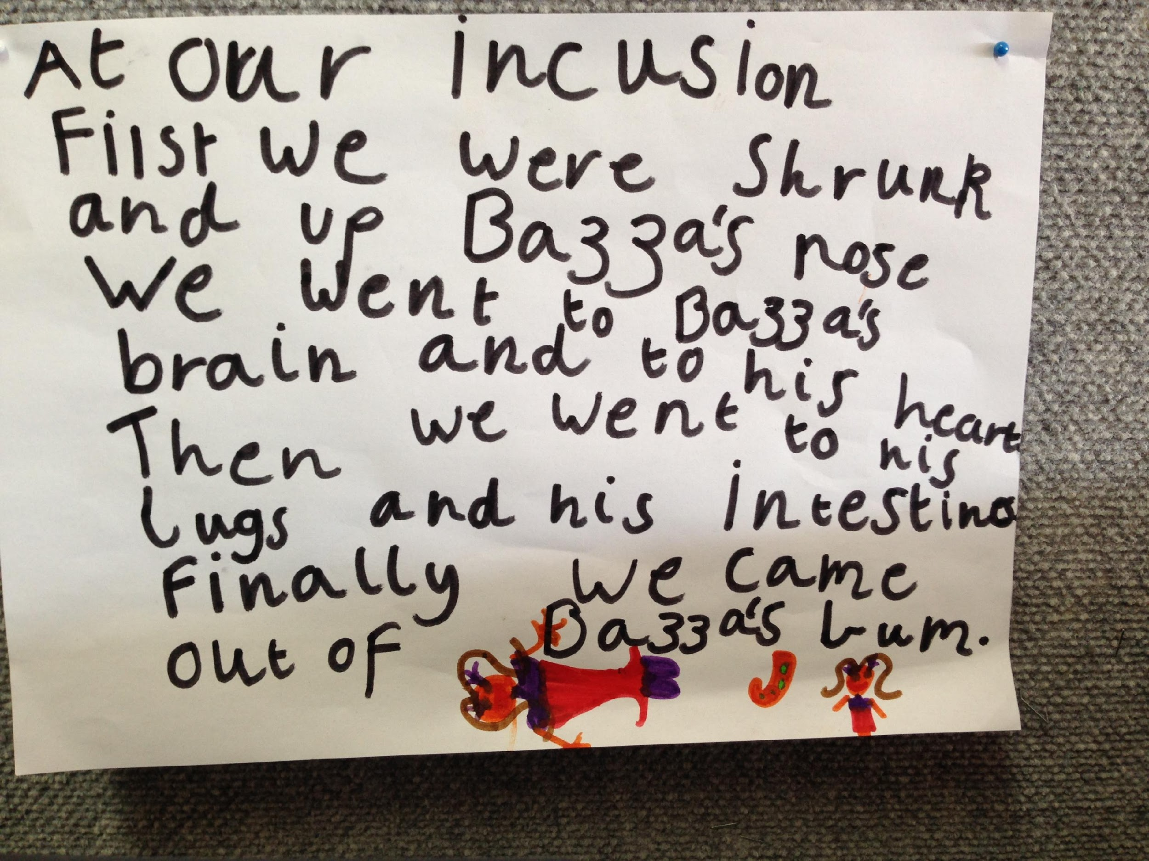
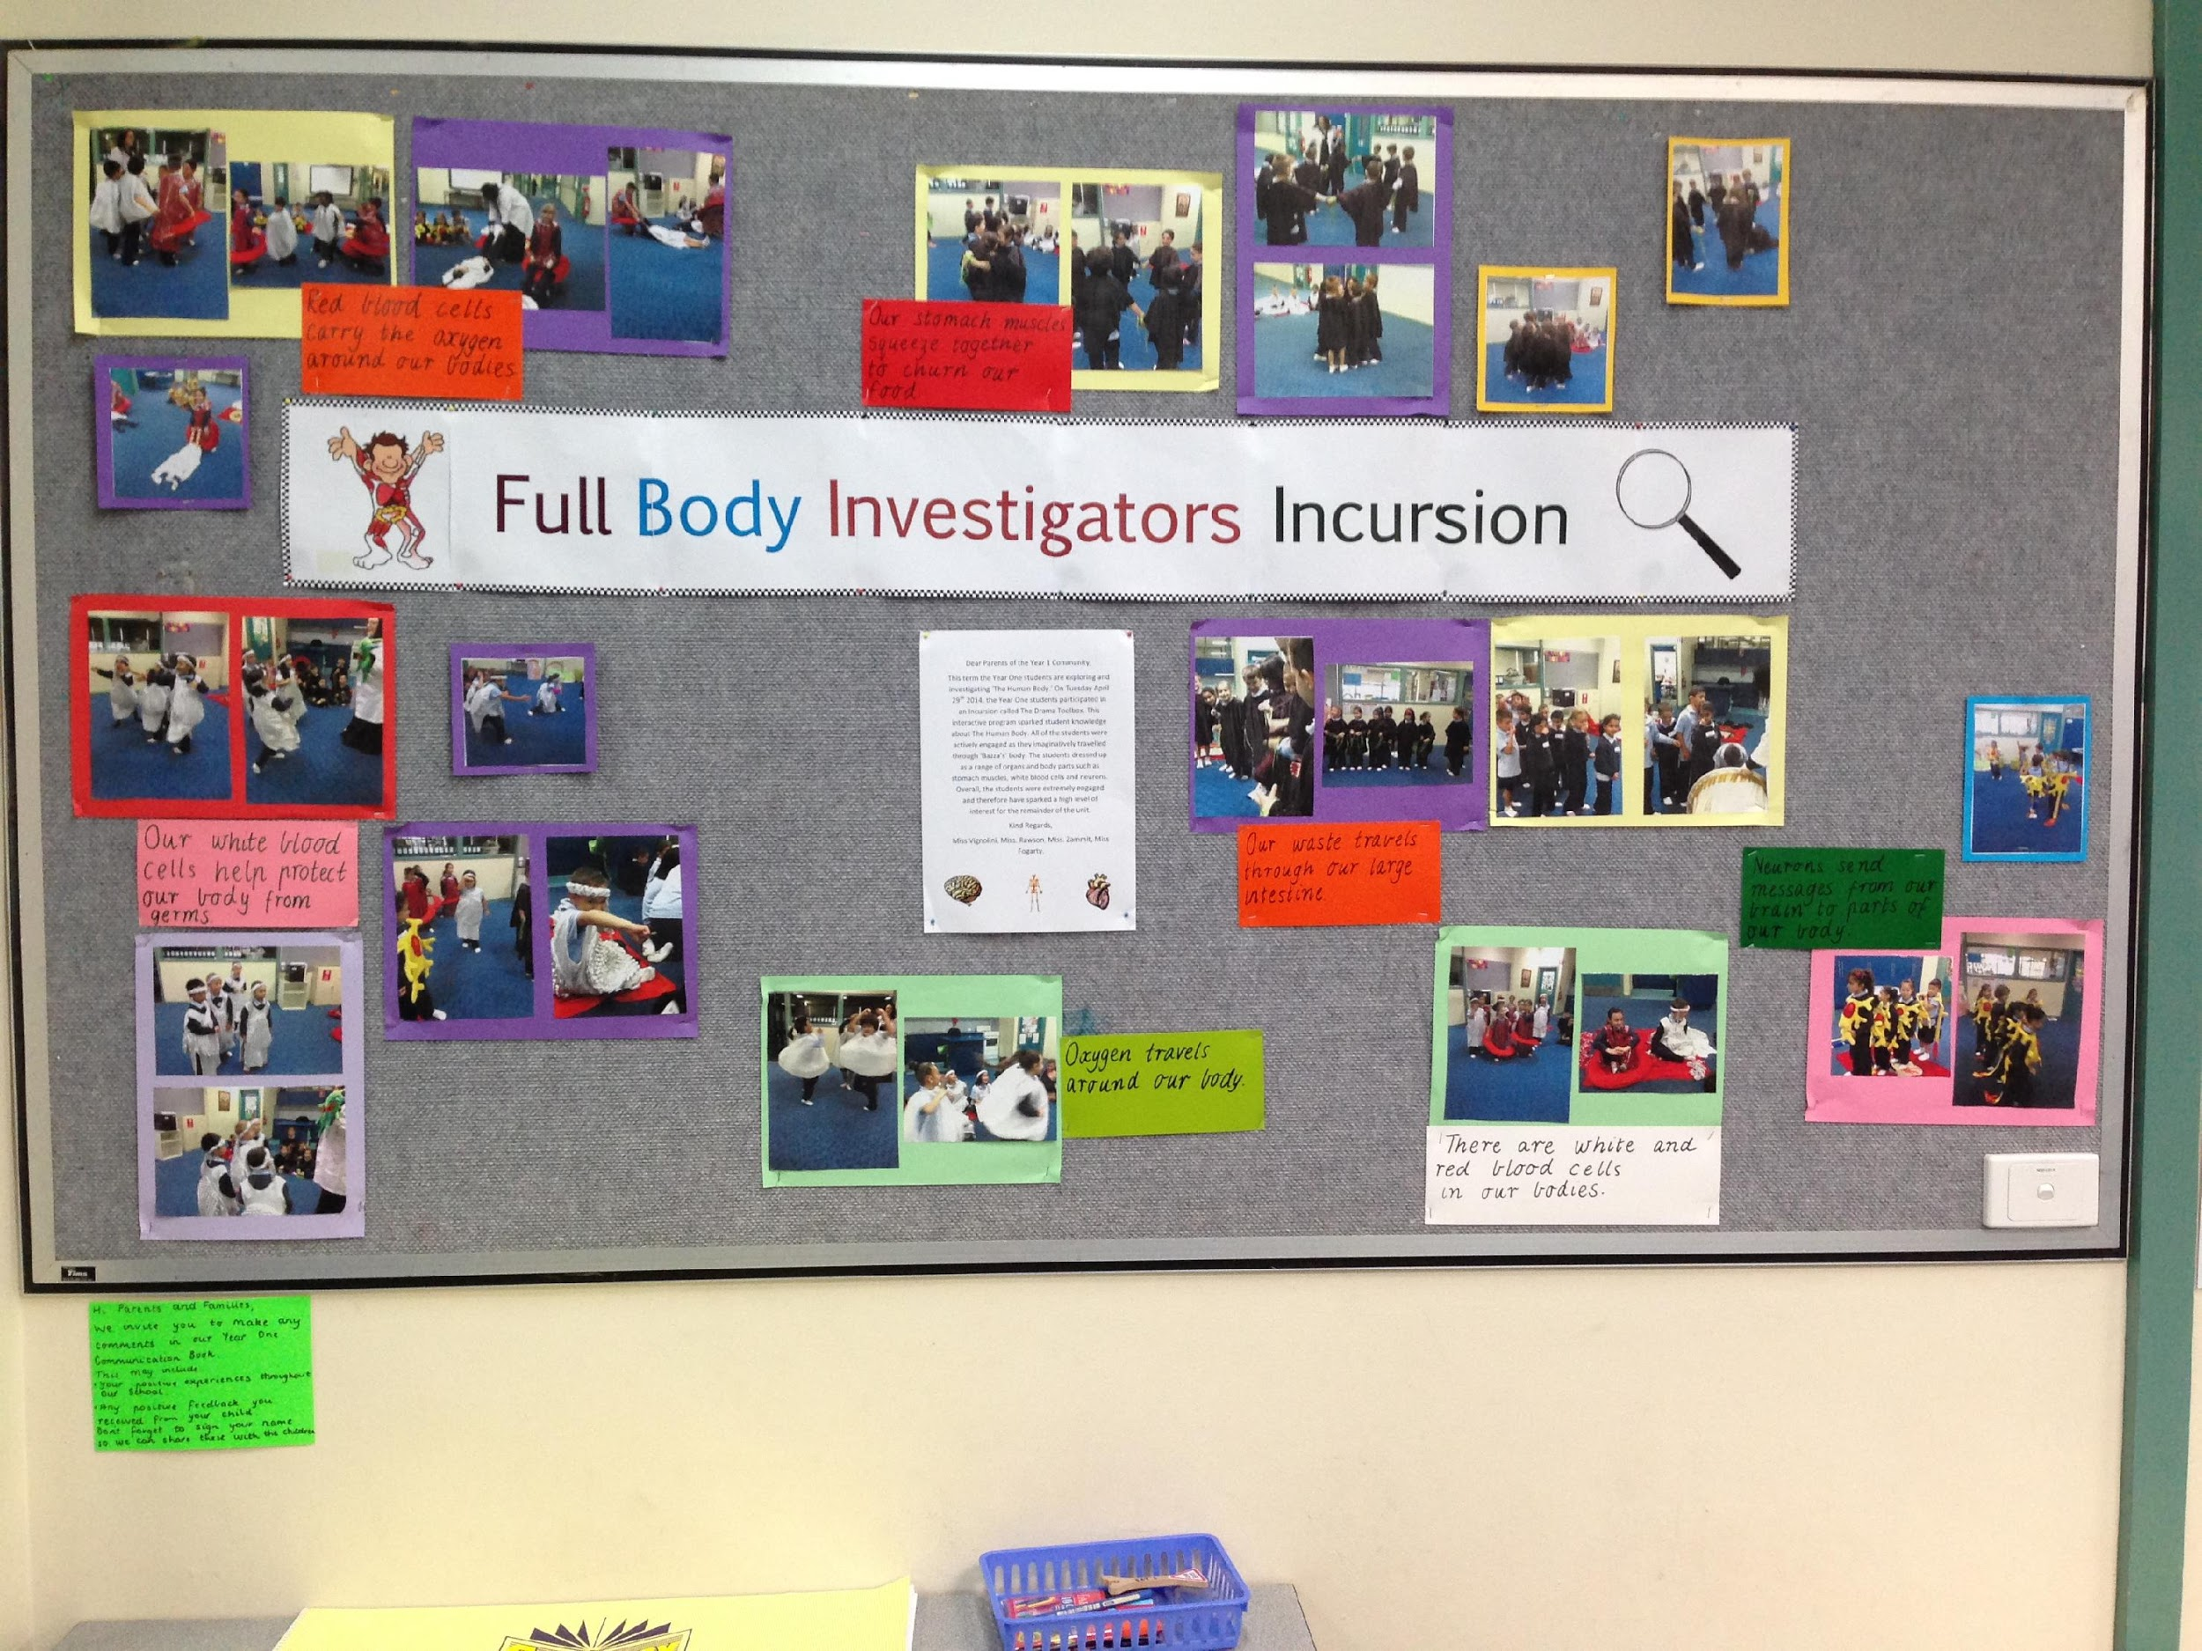

After the initiating experience of the Drama Toolbox session students had many wonderings about the body and in particular the digestive system. To support the further inquiry investigation teachers organised a walk to the local shops to buy food to make a healthy lunch, and a visit to the local leisure centre to find out about different activities they could participate in. This provided rich opportunity for language experience as well as enabling the students to make discoveries about the things they were wondering.

In Discovery teachers had set up a range of ‘areas/stations’ across indoor and outdoor learning spaces to encourage student investigations. Materials and stimuli provided encouraged students to further explore the human body as well as engage with art and craft investigations, writing and reading, construction, role play and some investigations into other areas children had expressed interest in. Many students explored concepts about the human body including; making models out of plasticine of the human body, role-playing a hospital (one little girl wrapped herself in red satin and said she was a red blood cell), ‘germ school’, books being written about the body, and students using the language/vocab of the unit in meaningful ways. Students were able to share amazing facts about the body they had learnt as well as make connections to what kinds of foods and activities would help to keep them healthy and happy.

Not all students in Discovery engaged in play related to the human body topic. Some children constructed amazing buildings, some role-played knights and princesses, one boy wrote a book about his passion; dinosaurs.

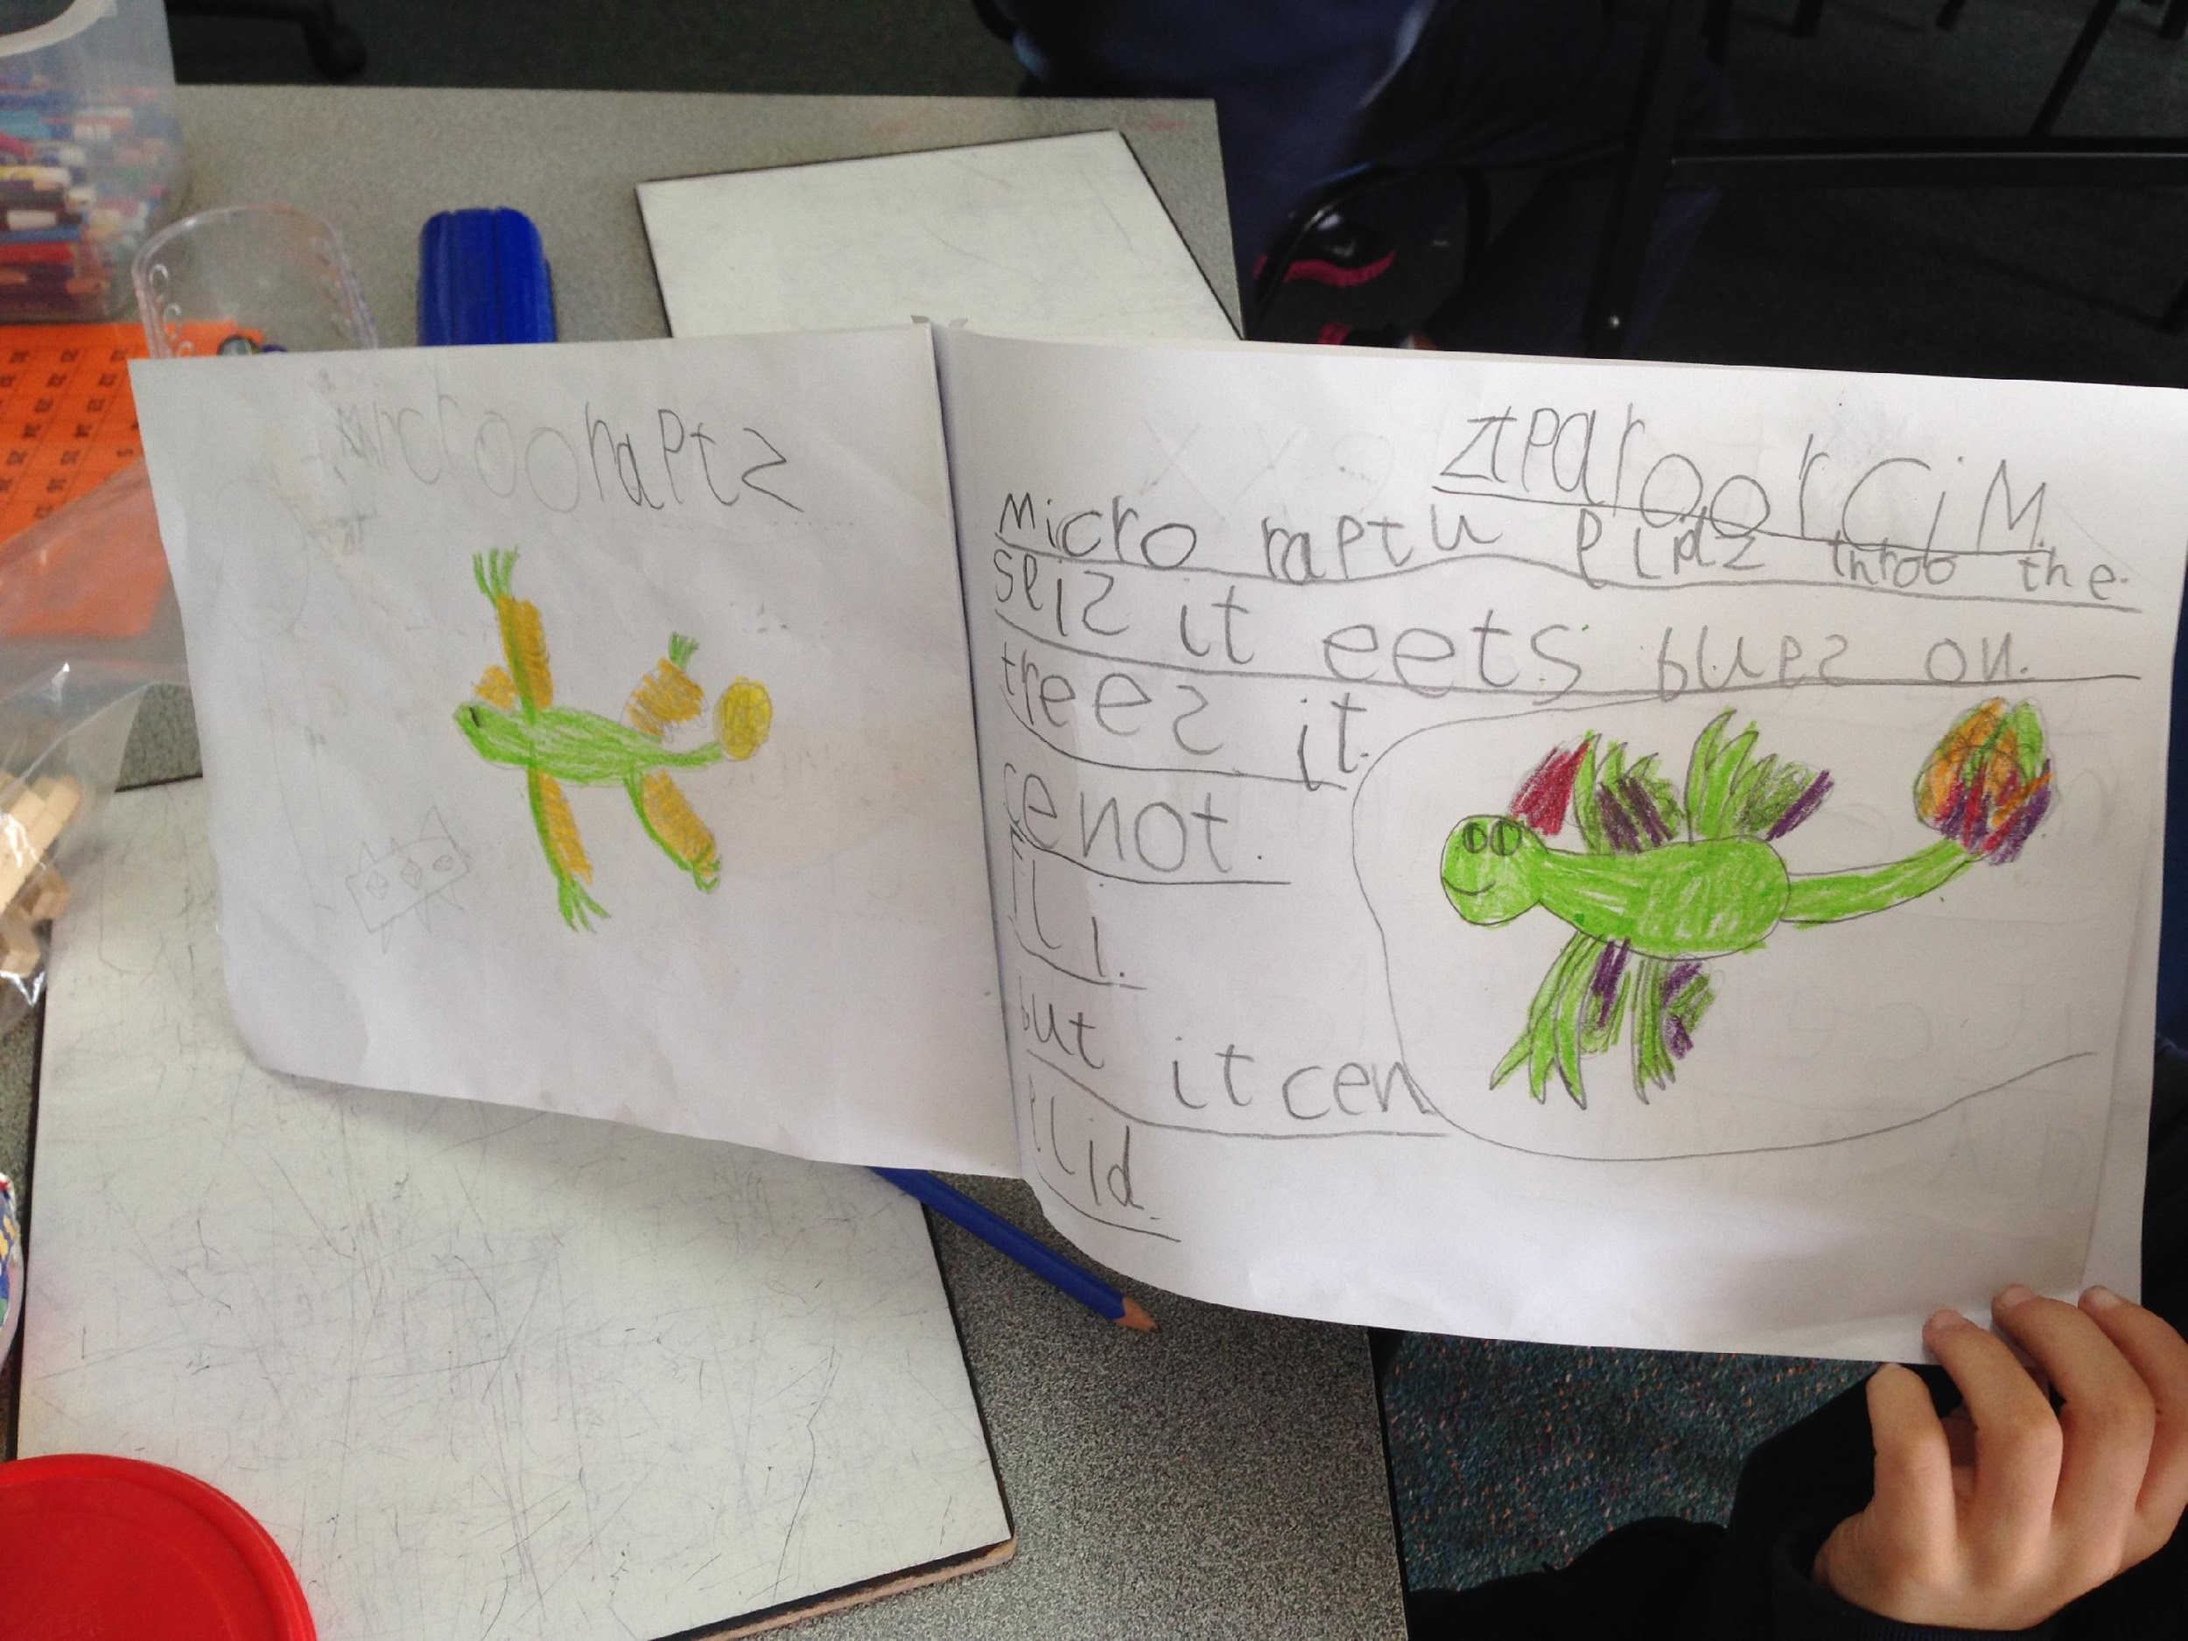
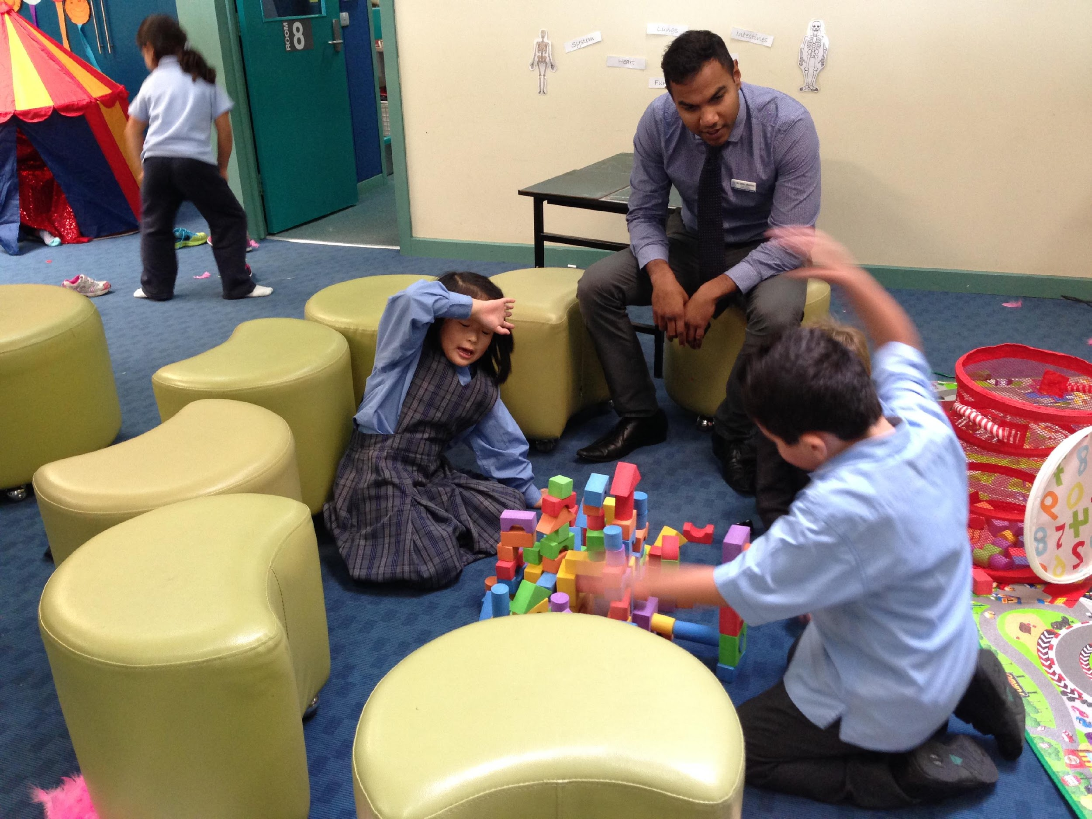

This learning may not have happened if not sparked by the strategic immersion experience planned by the teachers. In the words of Tina Blythe:

We want to give our students time to explore what intrigues them, and we want to make sure they visit the important sites they might miss without guidance. (Understanding by Design)

Likewise, the students may not have explored the concepts and built their understandings in the many varied and creative ways they did without the opportunity to explore further in Discovery. The unit was very mindful of ‘the hundred languages of children’, and truly personalised learning for all students.

Benefits of the approach
Analysis of school-based data including the ROL (record of oral language), writing analysis, and reading observations will allow schools to track student learning over time. However, what we know and value about student learning encompasses so many other areas not so easily measured. From observations and discussions with many teachers over the past few years, benefits also include high rates of engagement, development of social competence, ability to problem-solve and increased confidence.

Deborah Leong and Elena Bodrova in their article Assessing and Scaffolding Make-believe Play (‘Young Children’ January 2012) discuss the benefits of well-developed imaginative play on young students’ learning. They see this learning as setting sound foundations for more formal learning that happens later.

Research provides more and more evidence of the positive effects that well-developed play has on various areas of child development, such as children’s social skills, emerging mathematical ability, mastery of early literacy concepts, and self-regulation.

Benefits of Discovery-based inquiry expressed by participants in the Discovery Cluster include:

- It builds on children’s natural curiosity
- It is developmentally appropriate as documented in the Early Years Learning Framework
- It develops oral language as a basis for language learning (Many Prep students start with low oral language in English)
- Transition from Kinder to school is more streamlined and connected
- The connection to literacy means what children are reading and writing about will be meaningful and relevant
- It is engaging for students
- It allows for connections to the wider community
- It allows for coverage of a wide range of interests and experiences
- It personalises learning for students
- It allows for open-ended learning catering for a wide range of abilities
- It is supported by research into play as a powerful learning context
- It develops students personal management and social skills
- It develops skills, behaviours and dispositions outlined in the General Capabilities of the Victorian curriculum

