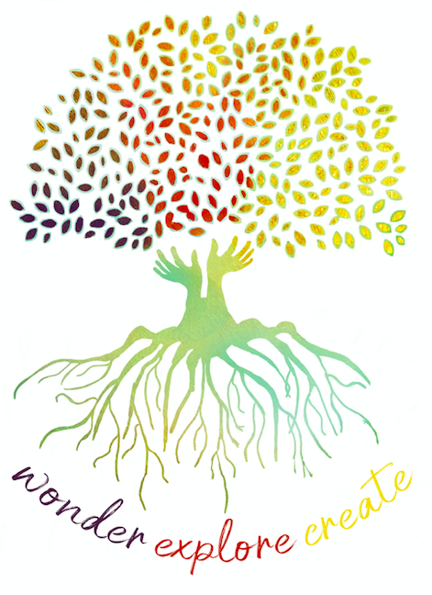
Learning Support Officers Professional Learning Module 1
Reflection Sheet

 | Content/Focus | What have I CONNECTED with? | What has EXTENDED my thinking? | What has CHALLENGED my thinking and what would I like to EXPLORE further?
PART B | What strategic roles can adults play during Discovery?
What are the features of a learning conversation?

(in conjunction with supplementary reading)
 | What might a learning conversation sound like?

