What type of Inquiry are you planning?

To inquire is to: actively engage in constructing and applying new knowledge by reflecting on prior knowledge, posing questions, investigating, analysing, synthesizing, reflecting and communicating.

The process used to inquire varies according to the context and the demands of the investigation.

Depending on the question being explored, the inquiry may require the students to investigate:
- Like scientists
- Like designers
- Like problem-solvers
- Like researchers
- Or may require them to go out into the field to gather data.

Depending on the developmental level of the students the inquiry may be experienced-based (for early investigators), or co-constructed with the teacher for more independent investigators.

Some inquiries are project based and require a ‘working backwards’ approach as these inquiries start with the end in mind.

Knowing what kind of inquiry you are about to launch into with your students allows teachers to be more strategic in their planning.

Co-constructed inquiries: 2 different approaches
1. Student choice inquiry after strategic immersion

identify area to be explored

strategic immersion in the content area

build core understandings

students identify an area of choice or question to further explore

Students act on their learning and apply it in a real life context
2. Project-based inquiry- working backwards

Start with an end project (goal) in mind

Engage students emotionally and cognitively with the project (goal)

brainstorm with students action steps needed to achieve end goal

allow student choice in how they move towards the end goal

explicitly teach skills needed for students to achieve the end goal
Experienced-based inquiry (Early Years)

Further Investigation:
Identify questions/wonderings triggered by the experience. Scaffold ways for students to discover answers to their wonderings.

Preparing for the experience
Consider what needs to be put into place in order for children to fully access the experience.
Shared Experience
Plan a ‘hands-on’ experience that allows students to explore a concept or topic first hand.
An initiating question leads students to enter and explore a big idea through the experience.

Language Experience:
Use the experience to instigate real opportunities for speaking, writing, reading, viewing and listening.
Discovery:
Give students the opportunity to further explore concepts raised during the inquiry play through student directed developmental play.

RESEARCH PROCESS

History, Civics, Health, Humanities

Identifying an area of interest to research

Posing questions
Developing questions to guide the research
Selecting and using sources of information
Finding appropriate resources
Analyzing and synthesizing information including identifying points of view
Recording key information
Reviewing
Connecting information discovered to prior knowledge and questions posed
Posing further questions and conducting research if necessary
Communicating
Selecting appropriate methods for sharing findings
Communicating new knowledge
SCIENTIFIC INQUIRY

Science
Hypothesising
Posing questions
Predicting

Planning and conducting
Guided investigations
Conducting fair tests

Processing and analyzing data and information

Evaluating (and reposing question)

Communicating
Inquiry Processes

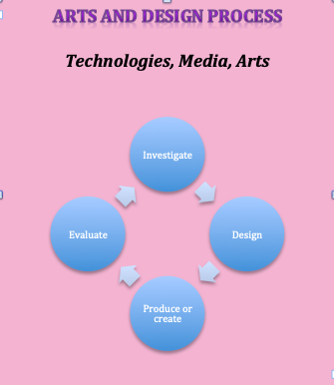

FIELD STUDY

Environmental, Earth and Health Sciences, Geography

Observing, questioning and planning

Collecting, recording, evaluating and representing
By observing, interviewing or using a range of sources

Interpreting, analyzing and concluding

Communicating

Reflecting and responding
PROBLEM SOLVING PROCESS

Action Based Learning

Define the problem

Brainstorm solutions

Choose the best solution

Make a plan

Follow the plan

Test and analyse solutions

How does the inquiry require students to investigate? Like:
Scientists
Designers
Problem solvers
Researchers
Environmentalists

What steps and skills are involved in each of these processes?

