provocations and invitations: reflections on the differences

FEBRUARY 16, 2016 ~ LOUISE JUPP

Since our last #ReggioPLC twitter chat, I have spent a great deal of time, thinking about and inquiring about provocations and invitations. I still believe, that as educators, we often use the terms interchangeably, and frequently, within the same sentence, thought or explanation, as if one term is needed to explain the other.
While at our lab school I asked several of the early years teachers about their definitions of provocations and invitations. There seemed to be some consensus that provocations were a result of observation of children’s actions, interests and investigations, reflections on the meaning of these endeavours and a subsequent choice to provide an intentional response (a provocation) to elicit further response from the children. Invitations were described as a less intentional response, something provided to the children with the intention to spark a reaction, rather than sustain one. One educator embraced the spark metaphor in her response. “an invitation is the spark, a provocation fans the fire”.
When I first walked into the lab school, bright light drew my attention to work children had done with clay, wood and the representation of a tree. Educators added a real tree branch before the children arrived, framed by the light from the overhead projector. During my class break I stepped into the hall to document some of the children’s work.
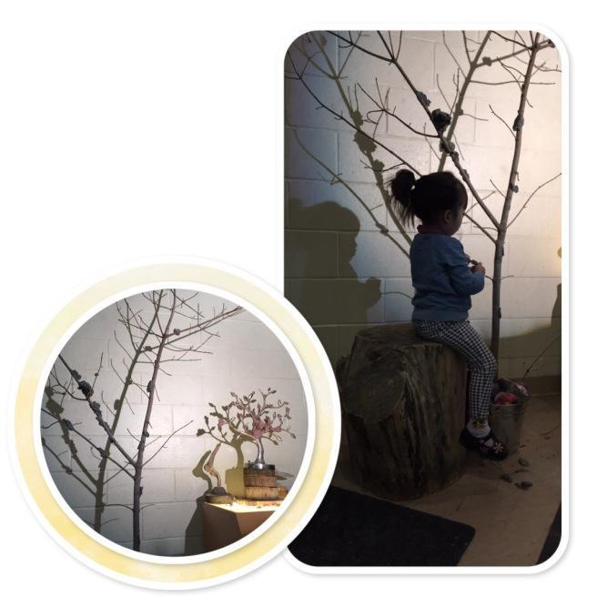
As the children continued to thoughtfully place clay on the tree branch, I spoke with their teacher, as she shared her thoughts about provocations, and I certainly felt like I was witnessing one. The work with the image of the tree and clay, the driftwood on the tree cookies, had been created by the children. The addition of a concrete representation of a tree, more clay and the light were added provocations meant to elicit a response. She had observed attention to detail, balance, making meaning of trees, speaking with clay, and had provided an opportunity for the children to continue their work.
Teachers endeavour to continually provoke children’s natural propensities to search for meanings, to pose questions of themselves and others, and to interpret the phenomena of their own lives. (Cooper, The Hundred Languages of Children, 2012).
I returned to my class for the second half. Once class was over, I peaked into another lab school classroom to see what had transpired since the early morning. I knew I wanted to document the work the children had been engaged in around inclines and ramps, but my eye caught a display in the middle of the room.
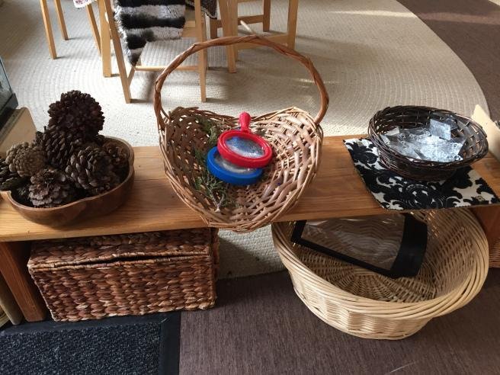
My initial thought was that an invitation had been created to look closely, knowing the magnifying glasses would enhance this process. I felt like this display was an invitation as it felt like a gentle temptation, not a provocation “something that must be responded to, that we cannot ignore” (Wein). I assumed the pine cones, crystals and crystal snowflakes were chosen for their complexity and aesthetics. I may have been correct, but a moment later, a child walked up to the table, picked up a snowflake and looked at me. I picked up a crystal and did the same. In silence we tried out several different crystals. After several moments, we took the image altering material from our eyes and smiled at one another. Perspective, viewpoint, distortion, opacity, refraction, explored and enjoyed in total silence.
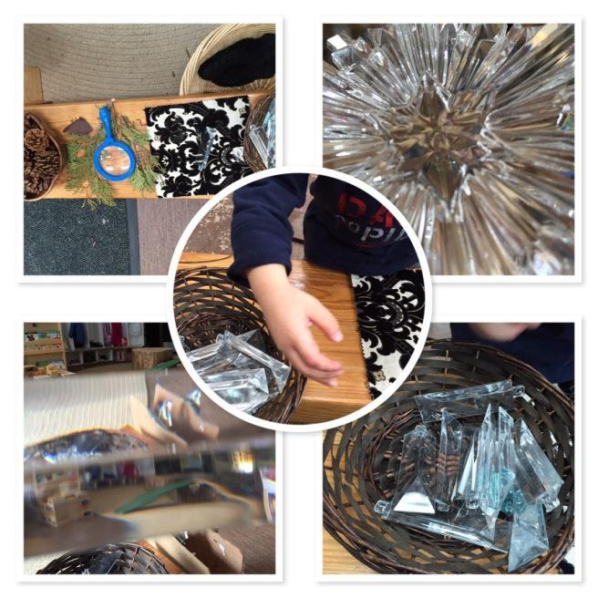
The invitational intention above was to look closely, to think about artifacts of winter with wonder. What transpired through my exploration and my engagement with another child was perspective, literally and certainly socially as we built connection and relationship through our altered viewpoints. The intent was invitational, but the materials, provoked multiple interpretations and discoveries. I pondered intention, intentional teaching and intentionality as I continued on with my intent to check out inclines and ramps.
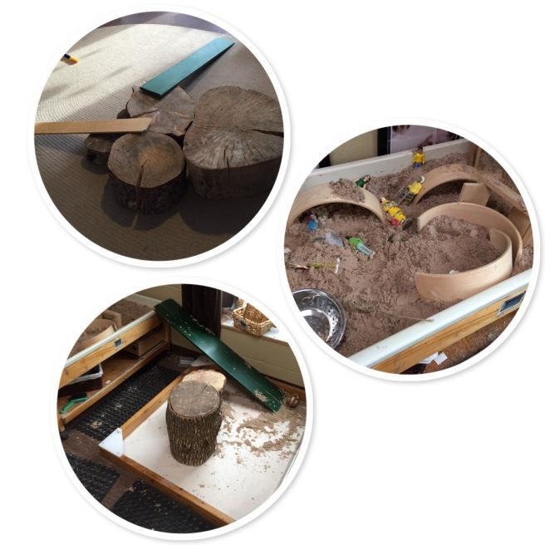
The work the children do with logs and ramps, along with the interest they display in the movement and transport of sand, lead teachers in the room to provoke further investigation of the principles of incline and movement. After a period of time spent dropping sand on the top of the wooden curves and watching it slide down, the children continued the investigation of the movement of sand down an incline by placing sand at the top of the green ramp, resting on the side of the sandbox. This work was provoked by educators, through the careful selection and placement of materials, after observation of children’s intentions and actions and reflections on possible learning.
Once you have taken the time to observe and reflect, it’s time to act on your thinking. After observation and reflection, you will be deciding whether you want to plan a response or if you need to find out more. One way to make that decision is to provide a provocation or a set of invitations for the children and then watch for the response (Stacey, Emergent Curriculum, 2009).
Time for one more visit. I knew that the children in one of the other classrooms were also very focussed on investigations with inclines and ramps. This continued work was evident but once again I was drawn in by the light of an overhead projector. As the educator began to explain the children’s work, once again a young child stepped in silently and very methodically gave me a definition of green with materials.
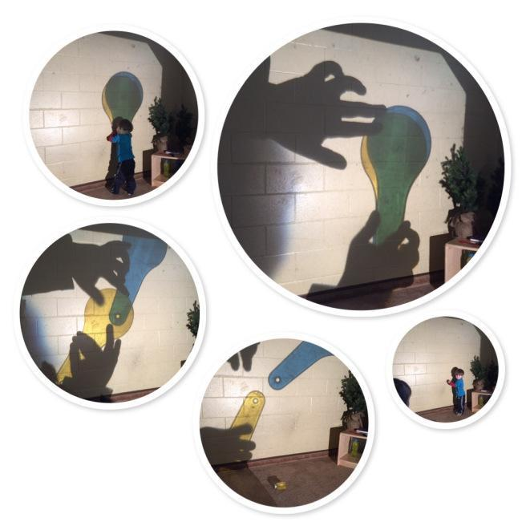
The children in the class had been given many invitations to explore with colour and scale. Recently their work had moved to a much larger scale as they expressed their knowledge, using materials as a language.

The materials we choose to bring into our classrooms reveal the choices we have made about knowledge and what we think is important to know. How children are invited to use the materials indicates the role they shall have in their learning. Materials are the text of early childhood classrooms. Unlike books filled with facts and printed with words, materials are more like outlines. They offer openings and pathways by and through which children may enter the world of knowledge. Materials become the tools with which children give form to and express their understanding of the world and the meanings they have constructed” (Cuffaro, Experimenting with the World, 1995).
And so I continued on with my day, off to teach another class, conscious that I was still wondering about intentionality, of materials, in our actions as educators, and where intentional teaching might fit in. A few days later, I did some research on the intentional teacher and found the quote below:
To be “intentional” is to act purposefully, with a goal in mind and a plan for accomplishing it. Intentional acts originate from careful thought and are accompanied by consideration of their potential effects. Thus an “intentional” teacher aims at clearly defined learning objectives for children, employs instructional strategies likely to help children achieve the objectives, and continually assesses progress and adjusts the strategies based on that assessment. The teacher who can explain just why she is doing what she is doing is acting intentionally—whether she is using a strategy tentatively for the first time or automatically from long practice, as part of an elaborate set up or spontaneously in a teachable moment” (Epstein, The Intentional Teacher, 2007).
And this quote made me think about our continued struggle with the differences between provocations and invitations. I wonder if there is a question about teaching decisions here as well. Intentional teaching has much to do with planning, curriculum and assessment. Intentionality is not about providing provocations and invitations with intention. Intentionality is the result of a mental state, the ability of the mind to form representations. Intentional teachers use intelligent materials to invite and provoke meaningful interactions and investigations, hypothesizing the learning that may take place. Intentionality happens when representation or meaning takes place in the individual mind. We can invite exploration and investigation with moments or materials with the intent to spark specific types of learning but as this learning happens within unique and individual minds, we cannot truly provoke the same learning for all involved.
The teacher sometimes works inside the group of children and at other times outside, around the group. From either vantage point, the teacher observes and selectively documents the children’s words, actions, interests, experiences, and activities. The teacher also observes and documents her own words and actions. Such observations are needed to interpret what is happening with the children and to make predictions and projections about how to go forward; on this basis, the teacher intervenes, joins with the children and their experiences and activity, and facilitates or provokes next occasions for learning-always in negotiation with the children and on the basis of agreement with them (Edwards, The Hundred Languages of Children, 2012).
As I reread the quote above, a few words stood out for me, observation, selective documentation, interpret and make predictions and projections. There is uncertainty in these terms. There is guess work in these terms. There is a process that is not democratic on behalf of the teacher. These words suggest processes that are at times uncomfortable, often uncertain and always requiring courage. But then there is the joy….“the teacher intervenes, joins with the children and their experiences and activity, and facilitates or provokes next occasions for learning-always in negotiation with the children and on the basis of agreement with them”. In the end we provoke again, we negotiate and agree and hopefully as teachers we learn that to teach is to accept with grace and humility a constant state of dissonance and disequalibrium, knowing that each nugget of knowledge comes with many more questions.

