What do you mean when you say Student agency?

I’ve learned that the term—and related terms, such as “self-regulated learning”—has a rich lineage of researchers and practitioners who have carefully defined it.

JENNIFER DAVIS POON

FELLOW, CENTER FOR INNOVATION IN EDUCATION

This article is the first part of a two-part series exploring student agency as it has been defined through decades of research and how we can apply the lessons learned in a culturally-competent frame.

What the heck is “student agency”?
Those like me who frequently invoke the phrase don’t always identify it as edu-jargon. If you know what it means, kudos. But, if you try rattling it off around your everyday friends, you may discover blank stares, empty head-nods, or worse, misunderstandings. Even frequent users like me tend to kick up dust around it when we are less intentional with our words.
When trying to explain the concept in layman’s terms, I have used a hodge-podge of half-right descriptions. I might say, “It’s when students take ownership and responsibility for what they learn.” Or sometimes, I have described it as, “When students take an active role in their education rather than having school ‘done to them.’” Whenever someone else defines it as “voice and choice” or “autonomy,” I have nodded my head in agreement without really pausing to wonder if that definition is right.
But, are all these things really the same? My mom-of-a-toddler brain hears “taking responsibility” as if it’s a behavior issue that a solid timeout will solve. “Voice and choice” conjures the meme of the shotgun guy, American flag in hand, fighting for his free will. And, what do we really know about what “active” versus “passive” looks like when it comes to the inner contours of the mind? My off-the-cuff definitions are adding to the noise.
It’s only recently that I’ve become much more disciplined in my use of the term “student agency” and how I apply it. Thanks to a research assignment on behalf of the Center for Innovation in Education’s Assessment for Learning Project, I’ve learned that the term—and related terms, such as “self-regulated learning”—has a rich lineage of researchers and practitioners who have carefully defined it.

There is no broad consensus on the definition of student agency…That said, by looking across researchers, practitioners, and other thought leaders, common elements arise that begin to suggest a consensus.

JENNIFER DAVIS POON

FELLOW, CENTER FOR INNOVATION IN EDUCATION

Some definitional efforts are relatively new but many are much older. And, meditating on this question—what is “student agency”?—has given me a more sophisticated understanding of what “student agency” really means and how to develop it in students.
First, I should say, there is no broad consensus on the definition of student agency. Many different words are used to describe the concept, and sometimes the same words are used to describe different concepts. That said, by looking across researchers1, practitioners, and other thought leaders2, common elements arise that begin to suggest a consensus.
From these sources, the dust seems to settle on a concept of “student agency” that involves four distinct components. The first three are temporally linked covering future, present, and past:
- Setting advantageous goals;
- Initiating action toward those goals; and
- Reflecting on and regulating progress toward those goals.
Several sources also agree on a fourth dimension, that undergirds the others—a belief in self-efficacy. That is, whether one believes they can act with agency actually enhances or diminishes that agency.
For me, this multi-part definition clears the air by allowing me to situate related terms—like voice, choice, and ownership—as valid pieces that fit within a larger whole.
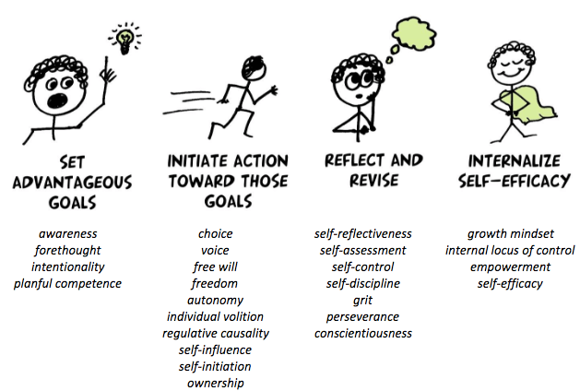
The four components of “student agency” and some related terminology and skills.
More importantly, this definition demystifies what it means to seek agency as an outcome for students. It’s not a binary “you have it or you don’t” quality. In Education Reimagined’s lexicon, Learner Agency is the “methodological development of both the capacity and the freedom of learners to exercise choice regarding what is to be learned and to co-create how that learning is to take place” (italics mine). Meaning: educators can work with young people to intentionally and progressively develop each of the four components.

SETTING GOALS
For example, one can help students become more adept at setting goals. Educators can design pathways of learning that promote students’ awareness of their current strengths and weaknesses relative to a developing sense of where they want to go. They can provide opportunities to practice, self-assess, and receive feedback on specific skills such as forethought, intentionality, and “planful competence.”
Of course, the point isn’t to set goals willy-nilly but to drive toward goals that are advantageous to the student. This is a value statement that calls into question what gets counted as a worthwhile goal and who gets to make that determination. The way we answer these questions has important ramifications on equity—a point I’ll dwell on in the second post in this conversation.

INITIATING ACTION
Once a direction is set, students don’t just gaze out the window of the bus. They drive. This second part of the definition—initiating action—invokes existential concepts such as voice, choice, free will, freedom, individual volition, self-influence, and self-initiation.
Educators can help students develop these capacities by providing choices or open-ended opportunities to select strategies and tactics for meeting a goal, allowing students to diverge from their peers as they explore something relevant to them. Educators can encourage independent learning by teaching effective learning strategies, such as organization, note-taking, rehearsing, and so on. Educators can also encourage initiative by creating learning environments that optimize motivation and engagement.
By providing students autonomy over “time, task, technique, and team” as they tackle learning objectives; or by making learning social through group work or community-based projects, educators can help students develop a sense of voice, ownership, and self-determination.

REFLECTING AND REDIRECTING
Even the best-laid plans and most meticulous follow-through can’t guarantee results. So, students with agency not only plan and act but also reflect and redirect. This involves perseverance and grit. It requires skills such as reflection and self-discipline. It is something that educators can encourage by structuring opportunities for students to externalize their thinking, self-reflect, and offer and receive feedback with adults and peers.
From an equity standpoint, it is also an opportunity for educators to complement the development of self-reflection and perseverance with practices focused on building critical consciousness as a way to understand and situate one’s agency within a “broader collective struggle for social justice.”

INTERNALIZING SELF-EFFICACY
The fourth and final component of the definition—beliefs about self-efficacy—is less outwardly apparent but no less important to instill in students. Research on “growth mindsets” by Carol Dweck has shown if students understand they aren’t born “smart” or “dumb” but have capacity to get smarter, they put in the extra effort necessary to achieve more.
Researchers have similarly applied the concept to agency, associating one’s belief in their ability to succeed with their level of effort and their ability to persist when facing challenges. Conversely, students with low self-efficacy exhibit learned helplessness, a belief they “have no power over what goes on around them, and nothing they do contributes to their success or lack of it.”
Educators can help students overcome learned helplessness and reinforce their self-efficacy through several tactics, such as providing multiple opportunities for students to develop and showcase mastery of their learning (as in a competency-based system); stretching students by targeting their zone of proximal development; sharing about peers and role models who overcome hurdles; instructing about and reinforcing growth mindsets; and explicitly attending to students’ physical and emotional states.

Using the research available to us, let’s be clear with one another about student agency…In doing so, we can better develop strong young adults capable of effecting positive change in their own lives and the world around them.

JENNIFER DAVIS POON

FELLOW, CENTER FOR INNOVATION IN EDUCATION

Keeping this four-part frame in mind has enabled me to more proactively focus on building student agency through my work, such as in ensuring all four components are expressed in self-assessment rubrics guiding educator practice.
Using the research available to us, let’s be clear with one another about student agency. It is not a fleeting behavior or an innate personality trait.
It is not (just) a manifestation of free will, or an exercise of one’s vocal chords, or a “buck up and be responsible” mentality. Rather, it is a multi-faceted skill—and disposition—invoking past, present, and future. It is students’ abilities to set advantageous goals, initiate action toward those goals, and reflect and redirect based on feedback, all the while internalizing the belief they can have agency.
The next time someone asks you about the meaning of “student agency,” will you consider all four components in your response? And, when you’re working with students and schools to develop agency in students, will you intentionally build skills and mindsets in each component? In doing so, we can better develop strong young adults capable of effecting positive change in their own lives and the world around them.

- Hitlin and Elder, Bandura, Zimmerman and Schunk, Heritage, Andrade, the National Research Council, and the University of Chicago Consortium on Chicago School Research, among others
- Education Reimagined, Summit Public Schools, New Tech Network schools, the Next Generation Learning Challenges, Students at the Center, the Hewlett Foundation, Transforming Education,Transcend, and the Assessment for Learning Project grantees

