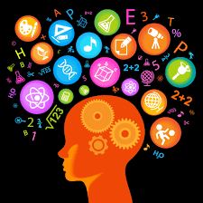
Tracking my Learning
What skills have you developed or used during your project?

PERSONAL AND SOCIAL CAPABILITY | CRITICAL AND CREATIVE THINKING
Self-Awareness and Management  - I can name my personal strengths  - I can identify when I use my learner dispositions  - I can set goals to develop my personal strengths or learner dispositions  - I am working towards being independent:  - I can persist when things get difficult  - I can show resilience when things aren’t working  - I can manage my time  - I can seek help when I need it  - I can try new things  - I can describe my learning using the language of learning  Social Awareness and Management  - I can work effectively in groups  - I can take turns  - I can listen to the ideas of others  - I can contribute my own ideas  - I can do my fair share of the work  - I can help resolve problems when the team isn’t working well  - I can reflect on how well I contributed to the group | Questions and Possibilities  - I can create questions to guide my inquiry  - I can use my thinking skills to come up with creative and imaginative ideas  - I can generate alternative ideas to solve problems  Reasoning  - I can give my point of view in group discussions  - I am working towards being an independent researcher  - I can find information with assistance  - I can find information by myself  - I can use information to answer my questions with assistance  - I can use information to answer my questions by myself  Meta-Cognition  - I can use a range of thinking strategies eg:  - Visualising  - Note-taking  - Learning from peers,  - Trial and error  - Brainstorming  - Comparing  - I can use and follow an inquiry process eg:  - Design Process  - Research Process

