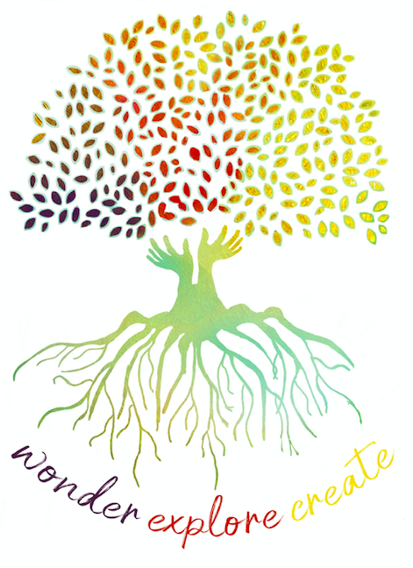
Learning Support Officers Professional Learning Module 1
Reflection Sheet

 | Content/Focus | What have I CONNECTED with? | What has EXTENDED my thinking? | What has CHALLENGED my thinking and what would I like to EXPLORE further?
PART A | What is Discovery Based Inquiry?
 | What might students be doing during Discovery?

