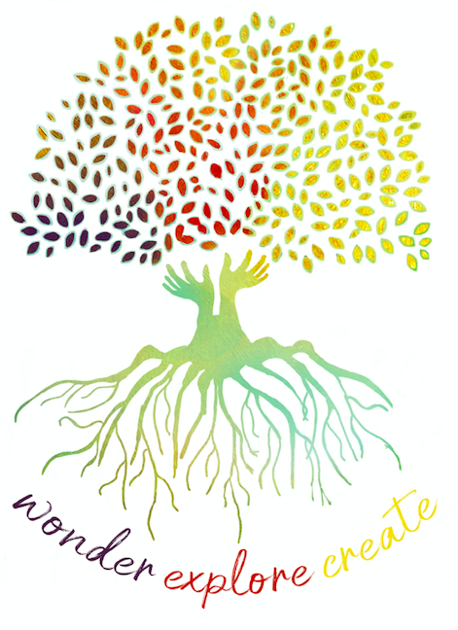
Guide to Professional Learning Module 2
PART A and PART B

How can we support students with special needs during Discovery?
How might we solve some possible hurdles we can be faced with when working alongside our special needs students?

Through this Professional Learning Module you will explore:
- strategies for supporting students with special needs during a Discovery session

- possible solutions to common problems that we may experience during Discovery
What you will need:

- Access to the handouts that were provided

Part A | Part B
Reflection Sheet  Reading: Special Needs or Special Rights? by Lisa Burman | Reflection Sheet  Supplementary Readings about Developmental Schemas

- Time to reflect and discuss with colleagues (where possible)

Please contact Deb or Vanessa if you have any problems accessing the Module
vanessawillis06@gmail.com
dvietri@bigpond.com

